
Newsletter
September 2022
Welcome to the Over 3’s.

smilechildcare’s Over 3’s staff team would like to take this opportunity to reach out to all our families, whether you have remained with us through the summer holiday period, have returned following the summer break or new families to smilechildcare who are just getting to know us. I hope that you have all had a fabulous break this summer and enjoyed the fantastic weather that we have been experiencing, making wonderful memories with your families.

Getting to know you
As this is the start of a new term, which runs from August through to December, we will be spending a lot of time getting to know your child, gaining their trust and helping them to feel nurtured whilst enjoying their nursery experience. Our goal is to develop strong connections between the children, parents and staff, which is very important to us as this supports positive relationships, which in turn supports the child to feel safe and secure in our environment and provides staff with the opportunity to learn the uniqueness of every individual child.
“I need you to be an adult who: builds warm, nurturing, respectful and responsive relationships with me, my family and the other adults around me in my ELC or school setting”
Realising the Ambition 2020 P69
We understand the importance of working in partnership with all our families and with this in mind we will be sure to regularly inform you of how your child’s day has been, along with what they have enjoyed doing throughout the day and created with their wonderful imaginations whilst at play. We know as the parent of your child you have a wealth of understanding of who they are and what they like most of all and by working together as a strong team we can ensure the best outcomes for our children.
Having strong connections with our families is very important to us, and we would love you to share ideas, suggestions and any relevant family adventures to allow us to continue to deliver a quality service and support your child to meet their full potential.
“The conversations we have with each family form the foundations of our relationships with them. During these conversations it is essential that we respect, understand and empathise to ensure our relationships are built on trust.”
Realising the Ambition 2020 P59

We feel it has proven to be in the child’s best interest to continue with the current morning and afternoon routine of dropping off your child to us at the nursery front door and again when collecting as this further supports your child to be independent and confident. This also allows us to maintain a safe area as the children can easily access all play spaces within the nursey with our free flow system.

Planting and growing
Throughout the year we have been assisting and supporting the children to research what we could grow in our garden. With our help the children have created a plan to allow us to plant, observe and record what we are planting and how it has grown. The children have successfully nurtured a large crop of potatoes, carrots, beans and onions as well as a few berries.
All the children have enjoyed this process, it has supported their learning & development in all areas of the curriculum, and has continued to hold the interest of all, including our younger children, with the guidance of our children in their preschool year, who are equally excited and keen to continue to take care of our thriving courgettes, brussels sprouts, leeks and, we are now trying to grow our own pumpkin……watch this space!
“Through gardening and play outdoors children have real, direct experience of the natural world. They learn in nature not just about nature. Through activities such as planting potatoes, harvesting apples, making bird cake, they experience the changing seasons, the cycles of life and death, and growth and decay.”
Brown - Early Childhood Practice: Froebel Today (2012)

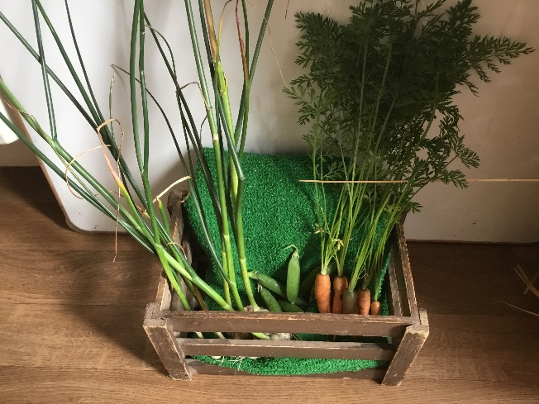
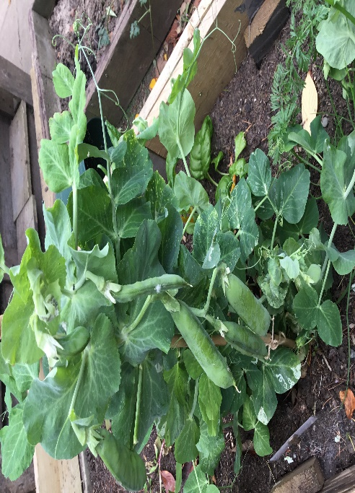

Play and our Learning Environments
Our fabulous outdoor areas continue to be the main learning environment for both children and staff, embracing the variety of opportunities this provides, whilst offering the children opportunity to play and development in the most exciting way. We are supporting your children on how to risk assess our wonderful outdoor spaces and how to use it to the best of their ability. We will continue to observe the children and ask what they like and what they enjoy most in the garden, allowing their requests to dictate their play and adaptions which are to be made to enhance their play, exploration and learning.

We have been spending time observing the many life cycle changes that happen in the garden throughout the seasons, and the children are very excited to record their findings using different methods; such as taking photos, drawing pictures, making treasure boxes and collecting the resources to use and explore in lots of different areas within the nursery. Please ask your child what they have been discovering and learning.

We are continuing to develop the outdoor area to allow for an enriched environment where children can be the leaders of their own learning.

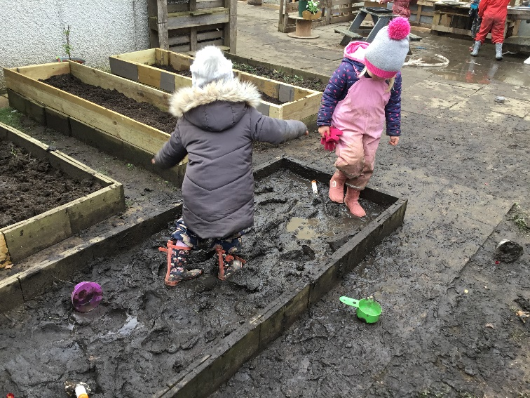
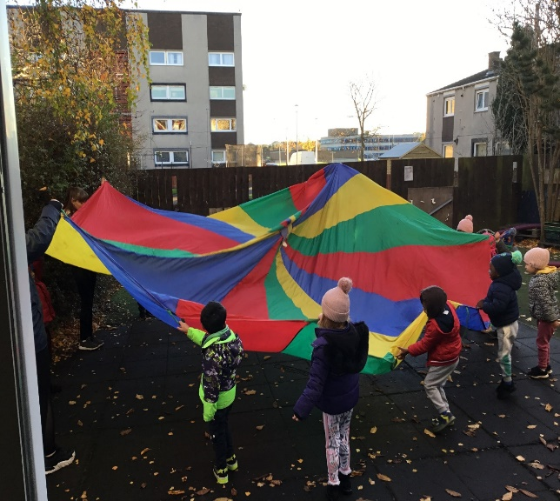
Outdoor clothing
It is our goal to continue to offer outdoor play in all weathers where children will have the freedom to explore all the elements, and enjoy them if they are dressed appropriately.
Please check your emails for information clarifying the appropriate clothing that your child must wear over the coming months.



Our nursery play spaces are set up to invite children to explore and be creative with a range of natural resources, loose parts and materials, supporting them in play and learning. We strive to have a relaxed and welcoming atmosphere, allowing the children to feel comfortable and happy throughout their day.
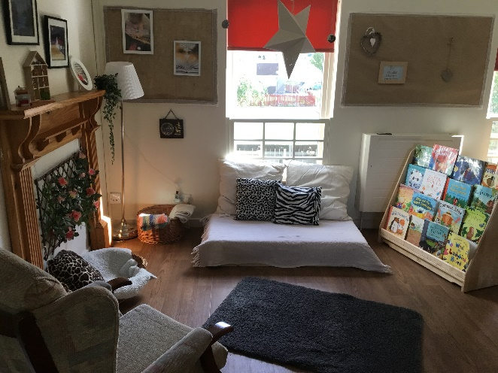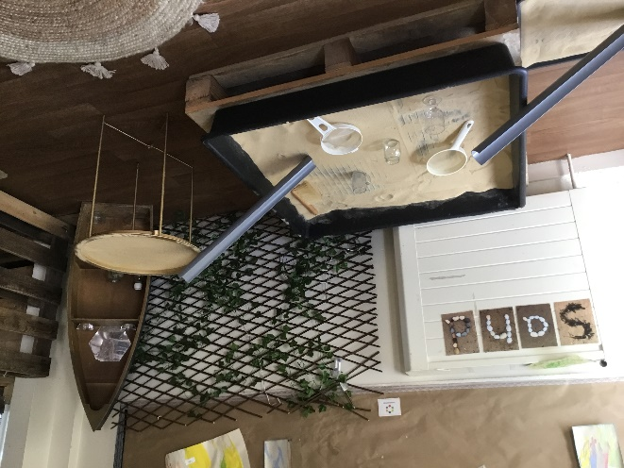

It’s a bug’s life
The children have been very interested in mini beasts and have been actively developing a bug hotel. We would be grateful if you could support your child to develop more knowledge outside of nursery, ideas for this are displayed at the front door.
We have been learning all about the life cycle of a butterfly watching the caterpillars grow from an egg into beautiful butterflies and through this process have learnt lots of new words. We released the fully grown butterflies in to our garden when it was time and the children enjoy looking to see if they have come back to visit, this further supports the children’s learning through science.

“I have observed living things in the environment over time” “curriculum for excellence, Education Scotland,2010”
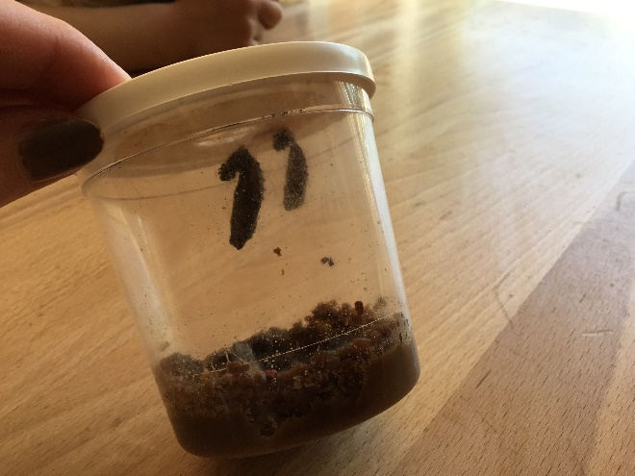
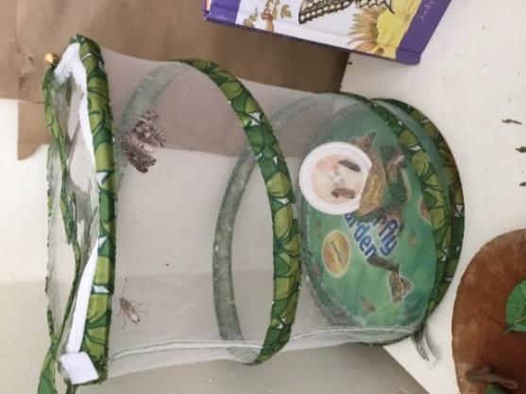

Standard and quality development

As always there is lots of development happening throughout the year. Our priorities for 2022 to 2023 will include:
1-Embedding quality frameworks
Realising the Ambition (Scottish government, 2020)
A quality framework (care inspectorate,2021)
UNCRC.

2-STEM
Support the children in STEM learning (science, technology engineering and mathematics).

3 UNCRC
looking at children’s rights and how the children’s voice supports planning and development throughout the nursery.
Throughout the year we will be inviting you to evaluate the setting through these priorities, your input is invaluable to us as it allows us to ensure we continue to deliver a quality service for you and your child.

We look forward to working with you to support our improvements.

Book lending library

We successfully ran a book lending library last term and as it was so popular, we have decided to extend this opportunity throughout this new term. In order for the library to be effective when you borrow a book, please remember to sign it out and then return the book when you have finished with it to allow other families to enjoy it too. Happy reading.

If you have books you would like to add to our library, please do pass them on for all to enjoy.



Meet the team

On every newsletter we would like to take the opportunity to introduce you to a member of our staff team, and give you a background of who they are and the training they have completed over the years.



Hello,
My name is Dawn Moorehead, I am the Over 3’s team leader. I have worked with smilechildcare since January 2006, where I started as a practitioner in the baby room. I gained an HNC in Childcare and Education in 1998 and then furthered my training by completing SVQ 4 SOCIAL SERVICES (CHILDREN AND YOUNG PEOPLE) in March 2017. I recently completed Froebel training at Edinburgh University, as part of my development project I developed our block play area, which now has its own room to support children’s learning and development.
I have mostly worked in the nursery class, but have spent time in other rooms and currently support the OOS team with school pick-ups.
At home I have 2 children, who both attended smilechildcare when they were small, Finn 15 and Eilidh 11 and are now both at high school.

Social Media
smilechildcare have a Facebook Business page as well as a Twitter page, where we share snapshots of the children and what they have been enjoying, experiencing, learning and exploring whilst in Nursery. You can also find further information about smilechildcare on our web page.
Please join us on our social media platforms.
Smilechildcare | Facebook
smilechildcareedinburgh(@smilechildcare1)/Twitter
http://smilechildcare.org

Communication
We continue to look ways we are sharing information with you all, and your feedback on this is welcomed.
If you have any further suggestions, comments or complements please send an email to mailbox@smilechildcare.org or share with the staff members.

Useful websites
that may be of interest to you

Parent Club - For Baby Box And All Your Parenting Needs
In car child safety - Safety Seats, Boosters, Law and advice (goodeggcarsafety.com)
Family and Kid's Activity & Events Guide for West Edinburgh | Families Online
Universal tax credits

