Welcome
Following the Easter break we are delighted to have our term-time children return as well as welcoming new children and families in to the Over 3’s setting. All the children have settled well, and it feels like they have always been here.
As this is the start of the new summer term the children will continue to explore and take ownership of their learning and play spaces as we eagerly experience the many natural changes we are seeing in our garden, going from winter to spring and then into summer. The children and staff have found lots of interesting things that have created lots of discussion and exploration.
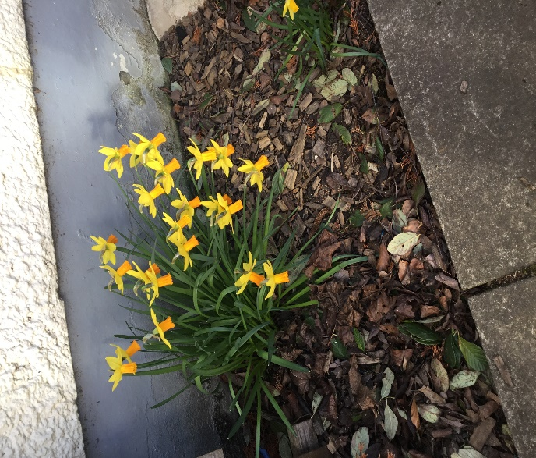
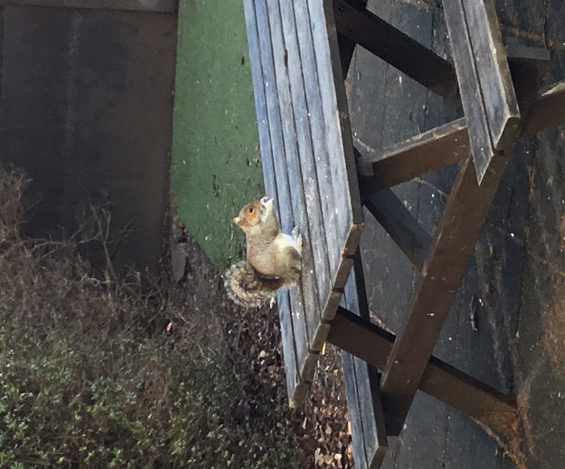

Planning/Learning Journals
From the feedback I have received from the recent questionnaires, parents have shared they would like to know more on what the children are learning whilst in nursery. We will now display the intentional planning at the front door for you all to see and please do ask questions if you would like to know more. Please remember the intentional planning is just a guide to what the children will be exploring and learning through resources, books, songs, research and exploration, however we do also support children’s interests with responsive planning, this might lead the children’s learning in a completely different interest, these are often added to the learning journals as a story for all and then linked to the individual children who were curious in the learning.
Other feedback we received were regarding the learning journals and keeping up to date information. Staff feel it is good practice to share the children’s day with parents/carers at collection to allow for open discussion and questions, we try very hard to keep the learning journals up to date with the children’s interests, learning and development as we understand how important this is for parents/carers. Please do keep asking the questions and we will try to keep this updated as often as we can.
Eco -schools
We done it!
smilechildcare and your children have been successful at achieving the
Eco Green Flag Award for the 11th year.
Every year the children with the support of the staff complete an environmental review to help us identify areas we would like to focus on and improve. Although we have a committee of children and staff who work on this, we have a whole nursery approach. Some of the activities we have been working on include:
- Planting lots of wildflowers in our garden to encourage wildlife in
- Planting and growing our own fruit, vegetables, and flowers
- Ensuring our outdoor spaces are kept clear from litter
- Monitoring our food waste/portion sizes to reduce waste
- Monitoring how we travel to nursey every day and look at ways we could change this to support a healthier lifestyle

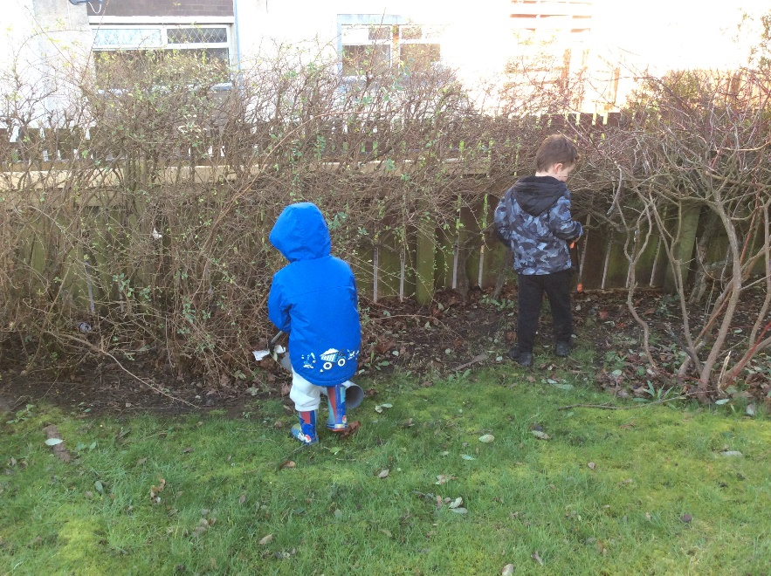
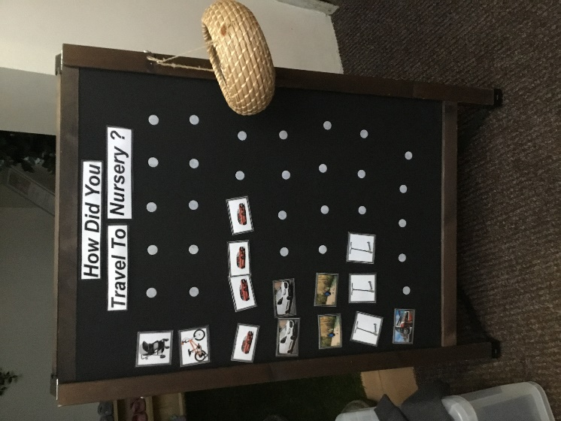
We will be starting our new application very soon and look forward to all your support and input. If you have any questions regarding this award, please contact Donna Rodger.

Mealtimes at smilechildcare
Mealtimes are a very important part of the children’s day and we want this to be a calm and inclusive time for all children. All children will have the opportunity to share at least 1 mealtime with us. I would like to share how these mealtimes work for your child whilst at nursery.
Breakfast – 8am to 9am
Breakfast cereals are laid out in self-serve containers children are encouraged to have 2 scoops and if they would like more they can, this helps us to ensure waste is at a minimum. The children pour their own milk or water and make their own toast/crumpets/pancakes if they would like this. Fruit is always available to the children.

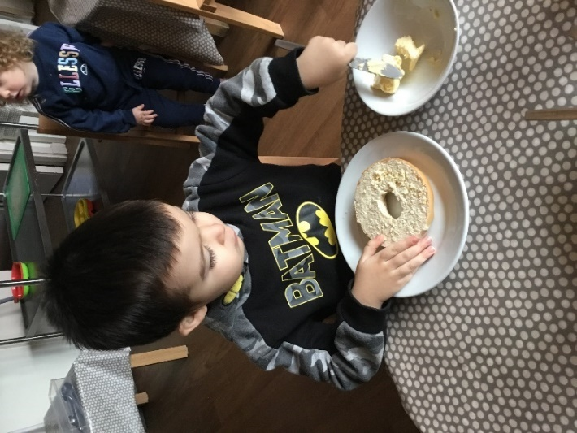
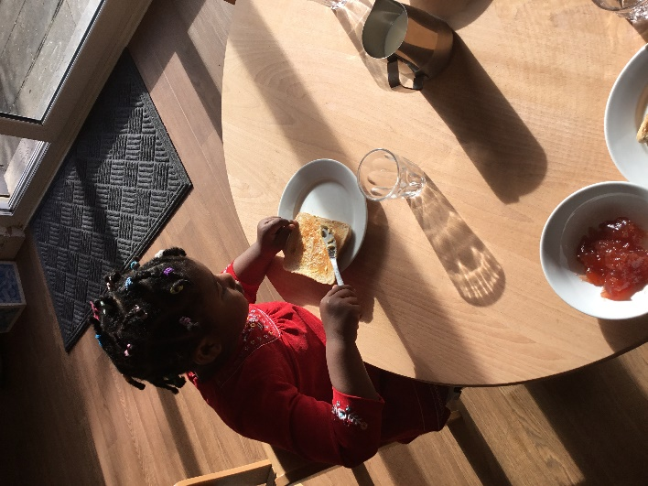

Lunch – 11.30am to 12.30pm
Children help to set the tables supporting them in cooperation, numeracy, problem solving, language and routines. We use crockery and glasses to reflect a home from home environment.
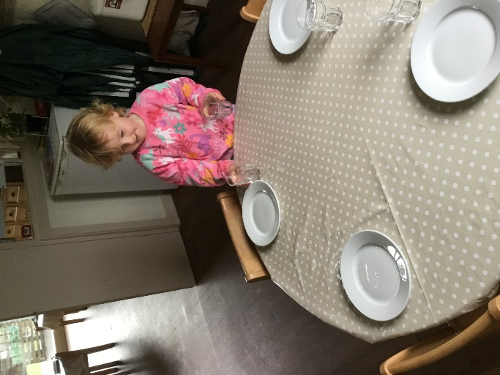
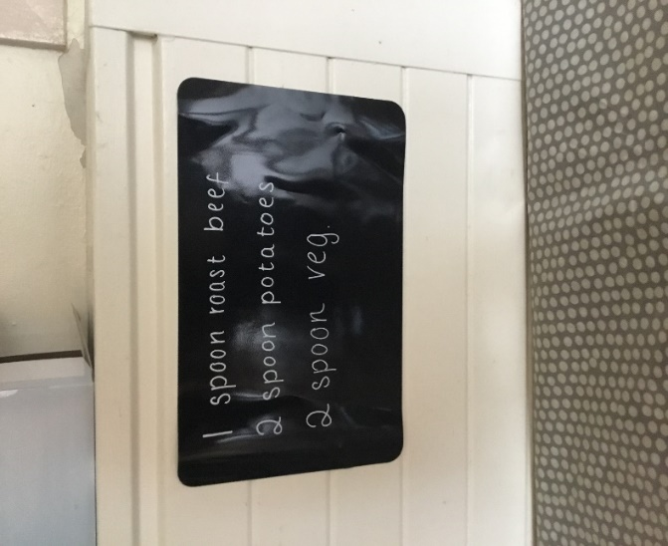

Food is placed in the centre of each table allowing the children to see what is for lunch and they self-serve their own meal, encouragement is given to the children to try a little of everything.
Dietary requirements are made where possible to ensure everyone has a healthy meal. We see mealtimes as a calm sociable learning opportunity, staff sit with the children discussing the meal, what they like what they dislike, supporting the children to build confidence and independence in serving their own meals. Children chat to their friends about their day, staff enjoy lunch with the children modelling good food choices and table etiquette.
Once the children have finished their meal they are supported to scrape any waste and place cutlery and glass on a unit ready to be sent to the kitchen.
Once lunch is finished the children are supported to wash their face and hands and brush their teeth ready to go and play.
Snack 3.00pm
We have a varied snack menu, from soup to crudities and dips. These are offered to the children on a self-serve buffet style, enjoyed by all. Children are active in sharing their views on mealtimes by using our choice boards allowing for their voice to be included in menu planning.
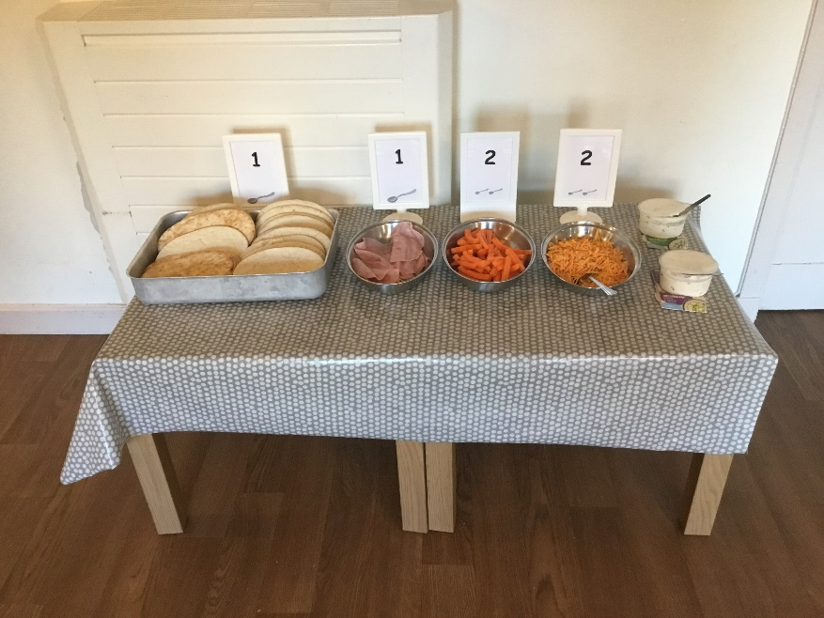

We try to share on the ejournals what your child has enjoyed at mealtimes daily, however if this is not completed, please do ask the staff. If you would like to see our menus they are available on our web page or I would be happy to email a copy to you. If you have any questions regarding our mealtime routine please speak to a member of the team.
Food activities
Children partake in fruit cutting activities for all the children to enjoy at snack time, this supports children to build skills in early mathematics and using their fine motor skills.
The children enjoy the opportunity to bake bread and make birthday cakes, these activities support the children in their social development as well as their language and numeracy.

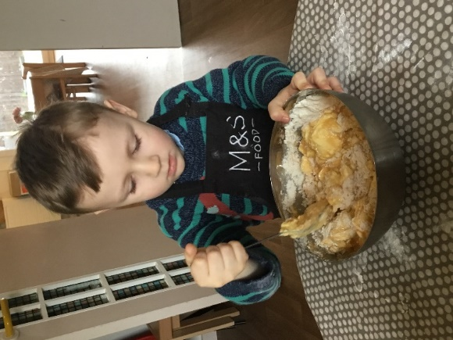
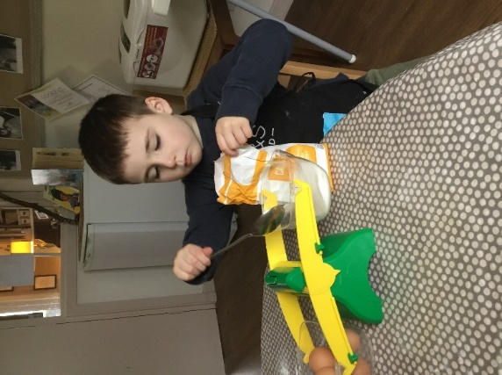

Standard and Quality Development

As always there is lots of development happening throughout the year. In August I sent out the evaluation from last year and how we progressed as well as our priorities for 2023 to 2024, as a reminder these will include:

1 - Children leading their own learning

2 - Tracking children’s progress and development

- Numeracy
- Health and wellbeing.
- Early language

3 - Children’s Rights UNCRC

Throughout the year we will be inviting you to evaluate the setting through these priorities, your input in invaluable to us to ensure we continue to deliver a quality service for you and your child.

We look forward to working with you to support our improvements.

Nursery Developments
Staff continue to develop the setting in line with the children’s interests and how they are engaging with the spaces, environment, and resources. We have noticed a big interest in creative arts, where children are designing wonderful crafts using boxes, things we’ve found in the garden and other interesting resources. I am sure most of you will have been the proud receiver of theses wonderful creations. With this in mind if you have any junk i.e. boxes, cartons etc please hand them in to us.

Our nursery play spaces are set up to invite children to explore and be creative with a range or natural resources, loose parts and materials supporting them in play and learning. The nursery strives to have a relaxed and welcoming feeling allowing the children to feel relaxed and happy throughout their day. If you feel there is something you would like to share with us, maybe a story, dressing up clothes from different cultures please talk to a member of staff, we would love to share your skills, cultures, and celebrations with all the children. If you have any resources at home you think would be of interest to the children please do speak to a staff member we are always looking at different ways to include the children’s home life into the nursery to enhance learning for all the children. Ideas for thought –
- Would you like to come read to the children in your home language?
- Do you have any talents you would like to share with the children?
- Do you have any interesting art at home. We would be delighted to work with you to share with all the children.

UNCRC (United Nations Convention of the Rights of the Child)– children’s rights Article 31 You have the right to play.
smilechildcare incorporate UNCRC/children’s rights principles into everyday practice for our policies and procedures, to hands on working with families. Over the next few months we will be highlighting several different articles from the UNCRC and exploring with you how we implement them and what this means for your child. The month of May we will be looking at article 31, please look out for further information on this. If you would like more information on UNCRC please go to parent club.
https://www.parentclub.scot/articles/further-information-about-childrens-rights-scotland

Meet the team:
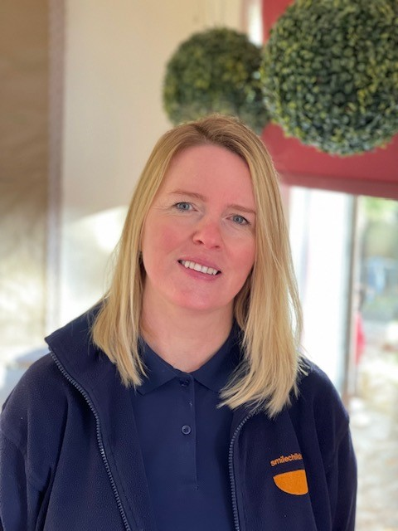
Hello,
My name is Dawn Naughton, I have worked with smilechildcare for 15 years, where I gained my SVQ 3 qualification in childcare and education. Throughout my time at smilechildcare I have mainly worked with the 0 to 3 age group, however in recent years I have been based with the 3years to 5 years which I enjoy immensely. I am currently the out-door lead, where I engage with the children to enhance our continuous provision in our garden, striving to be a more sustainable nursery through our planting and growing project.
I live at home with my husband and 2 sons aged 21 and 11, at the weekends I enjoy spending time with my family and friends.


Hello, I am Marek and I am the new cook within smilechildcare. I have been cooking for children for over 10 years and I get a lot of joy and satisfaction from it, I especially like it when the children share they enjoy their meals. I spend my free time with my family, I am football crazy, and I also enjoy board games.

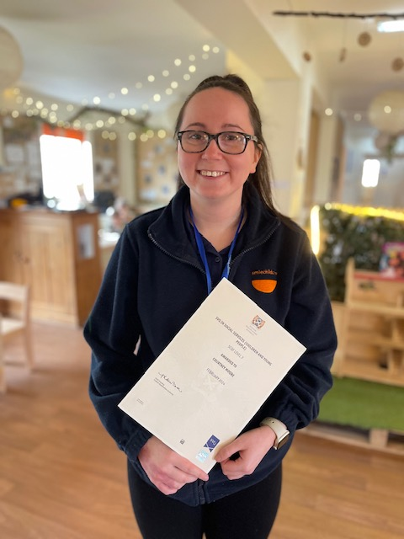
Hi I am Coutney, I am 20 years old and I have just completed my SVQ in children and young people whilst training with smilechildcare.

Social Media
We have a Facebook Business page, X page where we share snapshots of what the children have been enjoying, experiencing, learning, and exploring whilst in nursery. You will also find all the information on smilechildcare on our web page, if you have any queries.
Please join us on our social media platforms.
Smilechildcare | Facebook

smilechildcareedinburgh (@smilechildcare1) / X (twitter.com)

http://smilechildcare.org

Training
Over the last few months staff have been busy completing training requirements, we are committed to staying current in all areas to support the development and opportunities for all children.
2 staff have completed Child protection training.
7 staff completed the 12-hour First aid training required for Millie’s Mark
1 staff member attended a creative skills workshop over 6 weeks.
2 staff completed Autism in the early years.
1 staff member completed pondering pedagogy (8 week course)
1 staff member completed practitioner inquiry (Froebel)

Dates for Diary:
Parents Night -School Leavers Tuesday 14th May 2024
Play and Stay – For all Families Wednesday 22nd May 2024
School Leavers Trip - Thursday 6th June 2024
School Leavers Graduation - Friday 14th June 2024
Further information on these events will follow.
With a busy summer term ahead for us we look forward to lots of fun, creativity and play. We will be using the garden as our main play space; with this in mind can I take this opportunity to remind parents/carers that all children should attend nursery with suncream applied and staff will reapply throughout the day. This year we will be using Aldi factor 50 sensitive skin. A letter and permission form will follow, please ensure you complete this as soon as possible to support us in keeping all children safe and happy.

