Eco- Schools
As most of you will know this will be smilechildcare’s 10th year of holding our Eco flag and we are very excited to be working towards out 5th GREEN FLAG.
All of our settings continue to work hard to be Eco friendly, this starts with all settings carrying out an environmental review with all children, our younger children are supported with this by staff. This enables us to identify the areas that we would like to focus on. As you can see our commitment to being eco-friendly is strong throughout smilechildcare.
Litter - Litter is a mandatory topic we include in our action plan every year. our settings support children to keep their play spaces and direct surroundings litter free. Regular litter picks take place which allows the children to take pride in looking after the environment, it supports us to make links to learning in environmental issues, weather, recycling and many more curriculum topics. As you can see the children from all our settings actively enjoy carrying out this role in all weathers. Our environmental review helped the children identify areas that had lots of litter and informed us that our over 3’s setting needed to invest in new bins for the garden, as we continue to use our outdoor spaces more regularly.

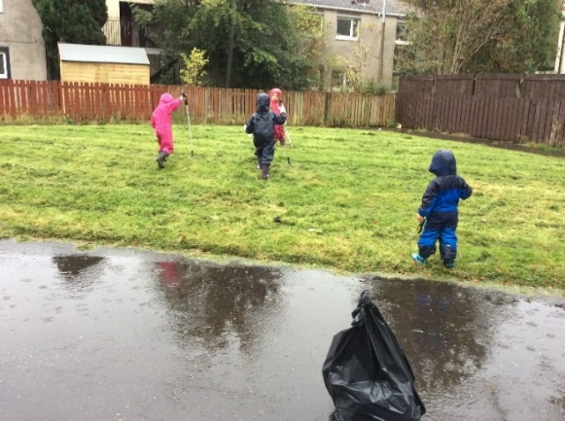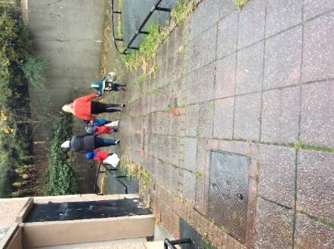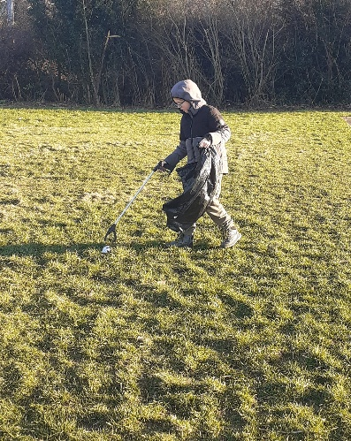
Over 3’s Under 3’s After school club

Planting and growing - In our settings we encourage the childern to learn through doing. We support the children to be active in planting and growing, working towards seed to the plate. This year the children in the over 3’s have plannted onions, leeks, potatoes, carrots and courgettes, as well as plannting rasberry bushes and strawberry plants. Our aim is to support the children to grow fruit and vegatables, encouraging a passion for planting, and trying new foods and linking it to learning. Keep talking to your child about this and as the vegatables grow we will share with their hard work with you. The children in our Under3’s have enjoyed planting bulbs and flowers, and the after school club have also begun their planting adventure.
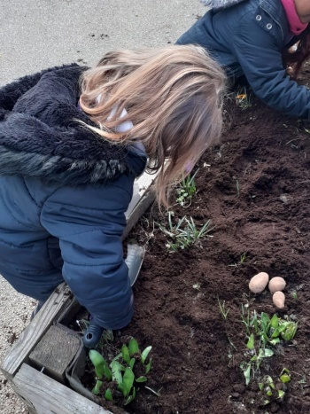
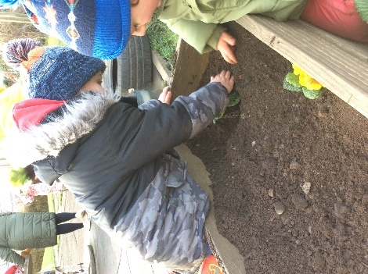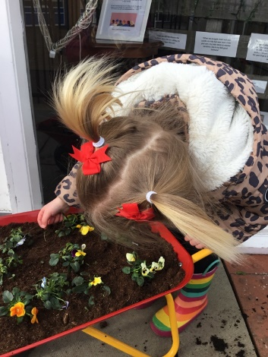
After school club Over 3’s Under 3’s

Bird feeders
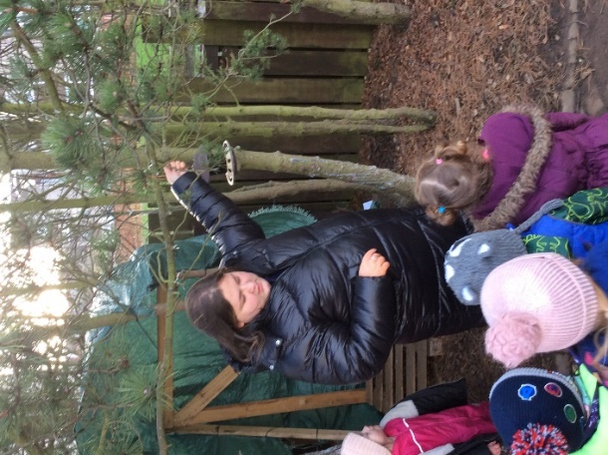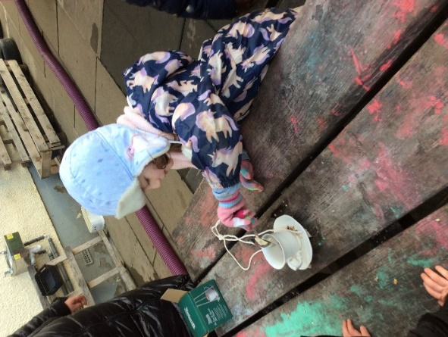
The children had shown great interest in the many birds that they observed in the garden, we can see lots of nests, this led on to a discussion about how the birds would get food over the winter months. The children reseached what we could do to help and we made and placed bird feeders throughout the garden. The children enjoyed watching the many different types of birds which eat from these, tracking when the feeders need to be re filled.

Hanging out our washing
This supports our eco goals by cutting down on the use of tumble dryers, and allowing nature to do the hard work. The children from all settings enjoy helping with this task
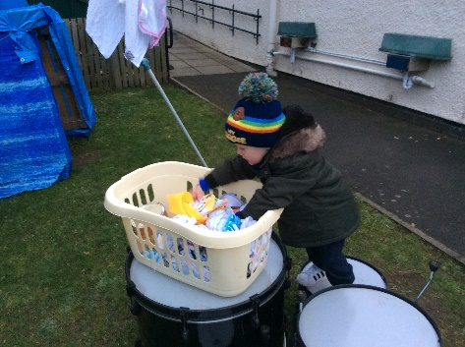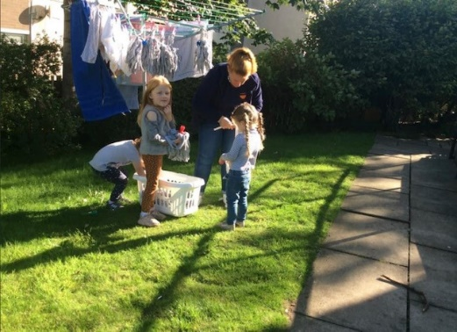
Health and wellbeing
Children in all our settings have acess to outdoor space daily. Our under 3’s and over 3’s settings both have gardens that are accessable all day if the children wish to be outdoors, in all weathers. Children in our over 3’s setting can choose to eat their meals out doors. Our outdoor play supports the children’s health and wellbeing and their development in many areas. Children who attend the after school club have daily access to the local woodland area. Staff have been on training to support the children in their mindfullness, to promote relaxation opportunities and yoga.
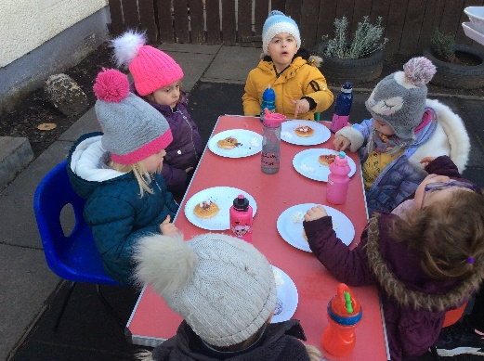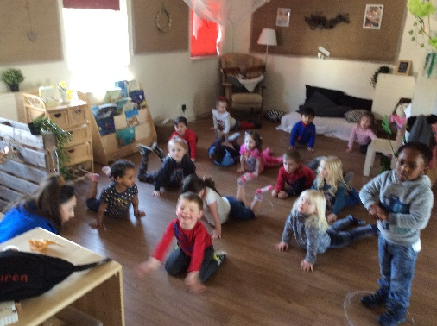
We hope you enjoy seeing what all the children have been active in, if you have any suggestions or questions about our eco journey please speak to staff in your setting.
Keep a look out for our new Green Flag.

