ELCC Menu
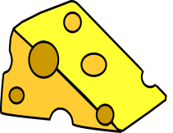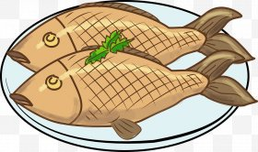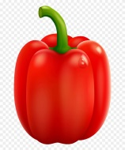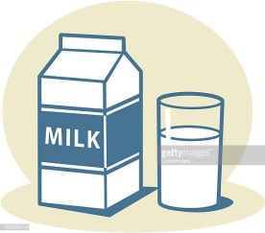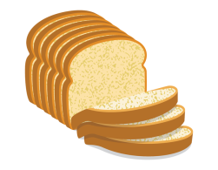

Week 1 | Monday | Tuesday | Wednesday | Thursday | Friday
Breakfast | Selection of cereals, toast fresh fruit & natural yoghurt  Gluten/Dairy | Selection of cereals, toast fresh fruit & natural yoghurt  Gluten/Dairy | Selection of cereals, toast fresh fruit & natural yoghurt  Gluten/Dairy | Selection of cereals, toast fresh fruit & natural yoghurt  Gluten/Dairy | Selection of cereals, toast fresh fruit & natural yoghurt  Gluten/Dairy
Lunch | Spaghetti bolognaise &  garlic bread  Dairy/Celery/Wheat  Lemon sponge  Egg/Wheat | Breaded fish roasted potatoes & broccoli  Wheat/Fish  Yoghurt  Dairy | Turkey dinner with mash potato mixed veg stuffing & gravy  Wheat  Melon assortment | Macaroni cheese with peas & sweetcorn  Dairy/Wheat  Orange quarters | Chicken hot pot with chunky veg & rice  Celery/Celeriac  Blueberry muffin  Wheat/Egg
Vegetarian Lunch | Quorn spaghetti bolognaise  garlic bread  Egg/Wheat/Celery/Celeriac  Lemon sponge  Egg Wheat | Fishless fillet roasted potatoes & broccoli  Wheat  Yoghurt  Dairy | Quorn dinner with mash mixed veg stuffing & gravy  Egg  Melon assortment | Macaroni cheese with peas & sweetcorn  Dairy Wheat  Orange quarters | Quorn hot pot with chunky veg & rice  Egg/Celery/Celeriac  Blueberry muffin  Wheat/Egg
Afternoon snack | Lentil soup with bread & butter  Celery Wheat Celeriac  Fruit | Bagels with soft cheese, ham & cucumber & carrot sticks  Wheat Dairy  Fruit | Tomato pasta with hidden veg  Celery Celeriac Wheat Dairy  Fruit | Carrot & sweet potato soup with crusty bread  Celery Celeriac Wheat  Fruit | Cheese on toast  Dairy/Wheat  Fruit

ELCC Menu 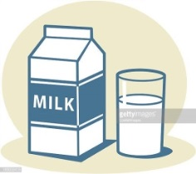

Week 2 | Monday | Tuesday | Wednesday | Thursday | Friday
Breakfast | Selection of cereals, toast fresh fruit & natural yoghurt  Gluten/Dairy | Selection of cereals, toast fresh fruit & natural yoghurt  Gluten/Dairy | Selection of cereals, toast fresh fruit & natural yoghurt  Gluten/Dairy | Selection of cereals, toast fresh fruit & natural yoghurt  Gluten/Dairy | Selection of cereals, toast fresh fruit & natural yoghurt  Gluten/Dairy
Lunch | Cheese & broccoli pasta bake  Wheat/Dairy  Yoghurt  Dairy | Sausage casserole with baby boiled potato  Wheat/Sulphite  Custard & banana  Dairy | Chill con carne with rice  Celery/Celeriac  Melon assortment | Chicken hot pot with chunky veg & sweet potato mash  Celery/Celeriac  Fruit scones  Wheat | Lentil & carrot soup  assortment of sandwiches  Dairy/Wheat/Celery  Yoghurt  Dairy
Vegetarian Lunch | Cheese & broccoli pasta bake  Celery/Gluten  Yoghurt  Dairy | Quorn sausage casserole with baby boiled potato  Egg  Custard & banana  Dairy | Quorn chilli con carne with rice  Celery/Celeriac  Melon assortment | Chicken hot pot with chunky veg & sweet potato mash  Celery/Celeriac  Fruit flapjack | Lentil & carrot soup  Assortment of sandwiches  Dairy/Wheat/Celery  Yoghurt  Dairy
Afternoon snack | Spaghetti hoops on toast & cheese sticks  Gluten/Dairy  Fruit | Selection of sandwiches  Wheat/Dairy  Fruit | Chicken noodle soup with bread & butter  Celery/Celeriac/Wheat  Fruit | Macaroni & cheese  Dairy/Wheat  Fruit | Sausage Jambalaya  Wheat/Sulphite  Fruit

