
Newsletter
December 2024
This term has been busy and full of lots of interesting and fun experiences.

The children have been very interested in the changes that are happening in our garden and have enjoyed lots of play with leaves, pinecones and discovering the big muddy puddles. We have spent time exploring why the leaves have all fallen off the trees and why it is getting dark earlier?
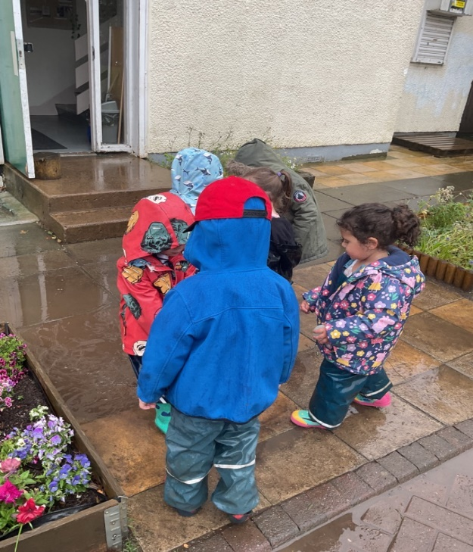
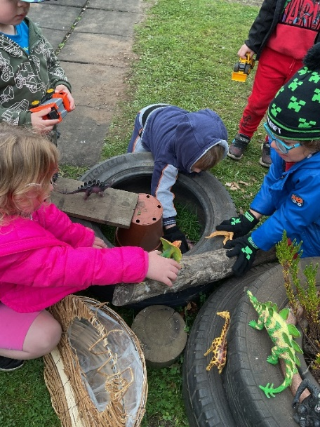

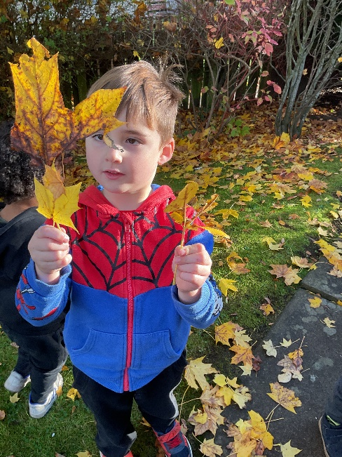
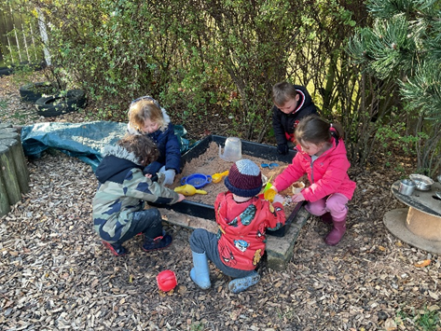

Daily access to be outside in nature, experiencing all weathers and seasons in comfortable suitable clothing continues to encourage my sense of wonder. - Realising the ambition 2020:31

This term we have explored the following areas:

We have been learning about Diwali, the Hindu festival of light, and would like to thank some of our parents for sharing their festivals, resources and celebrations with us.
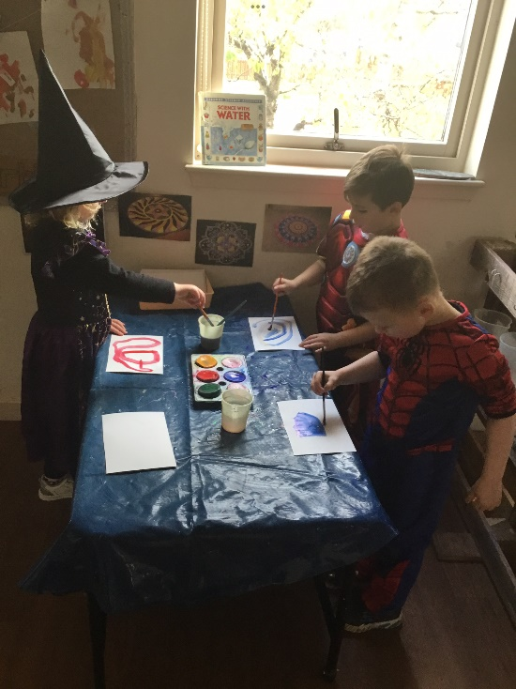
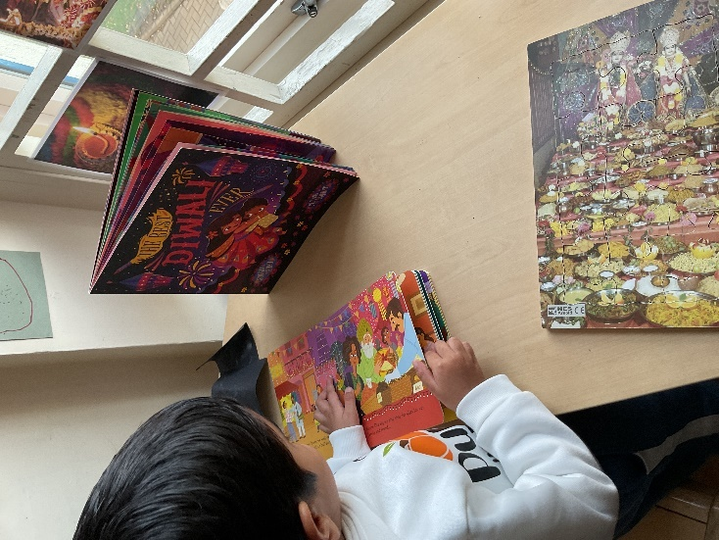

I am becoming aware of the importance of celebrations, festivals and customs in religious people’s lives. RME 0-06a - Curriculum for Excellence 2010
We spent a lot of time discussing fireworks, and fire safety. We have introduced our firepit, and discussing with the children how to keep safe around it. Please ask your child about the Blue Safety Rope! This has allowed for some great discussion and imaginary play from the children.
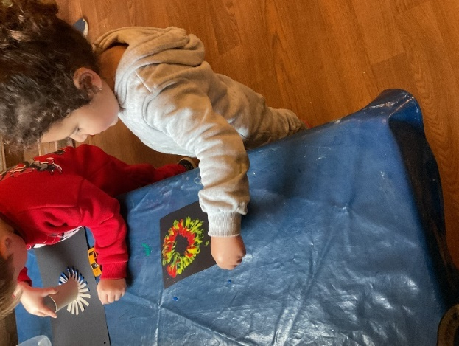
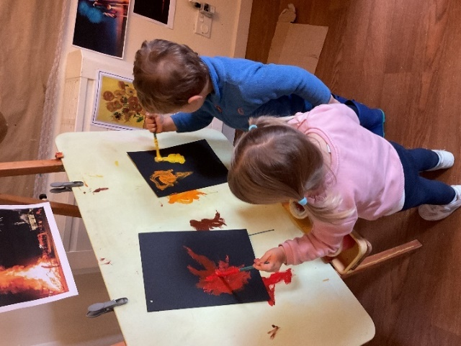

I am learning to assess and manage risk, to protect myself and others, and to reduce the potential for harm when possible. HWB 0-16a - Curriculum for Excellence 2004

Area of interest – Numeracy

The children have been showing lots of interest with exploring numbers, matching shapes and identifying numeracy in everyday objects, both indoors and outside. Your treasure bags have been a source of curiosity and wonder, thank you for sharing all your found treasures with us.

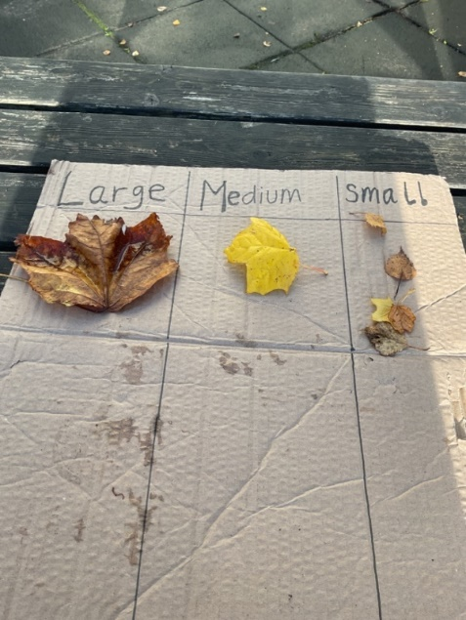
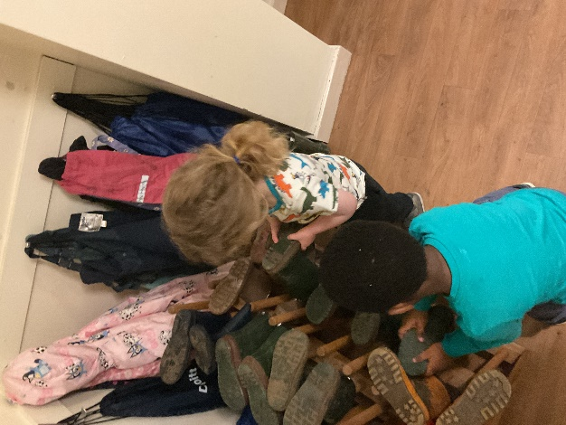

I can match objects, and sort using my own and others criteria, sharing my ideas with others.
MNU 0-20b – Curriculum for Excellence 2004
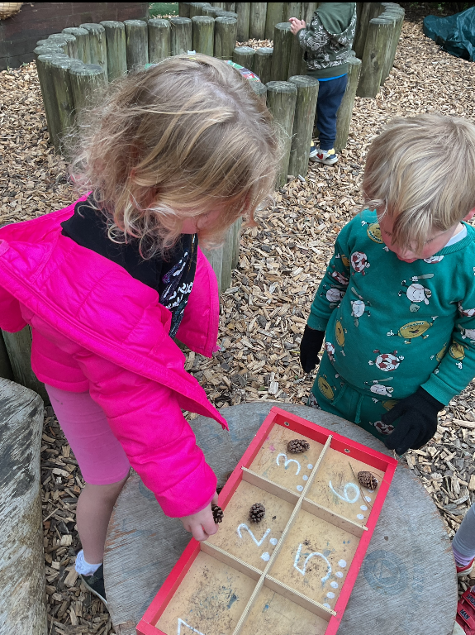
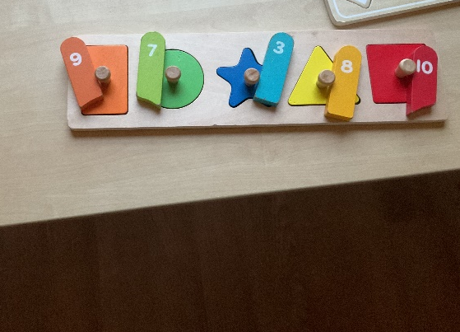

Numeracy and mathematical learning should be actively encouraged by providing different materials in different contexts to encourage opportunities for exploration, enquiry and problem solving. Realising the Ambition 2020:76

Lunch time review:
This term we have been evaluating our lunch time routine. Through observations we could see that this experience could be made better for the children and promote more choice and independence as well as helping the children to have a clearer idea of when they would be going on lunch to avoid interrupting the child whilst playing. The children continue to make choices on which sitting they would like to be on, we have added clearer visuals to allow the children to keep track of the time and introduced new lanyards for the children to wear to remind them of their choices. Please ask your child about these changes.
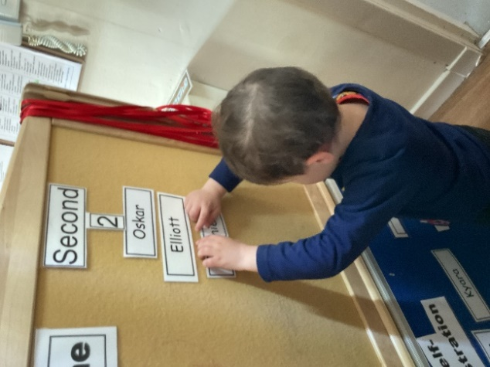
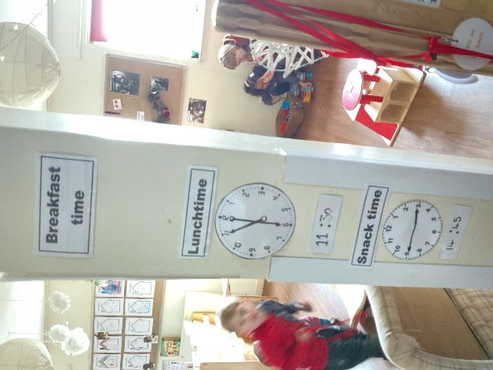
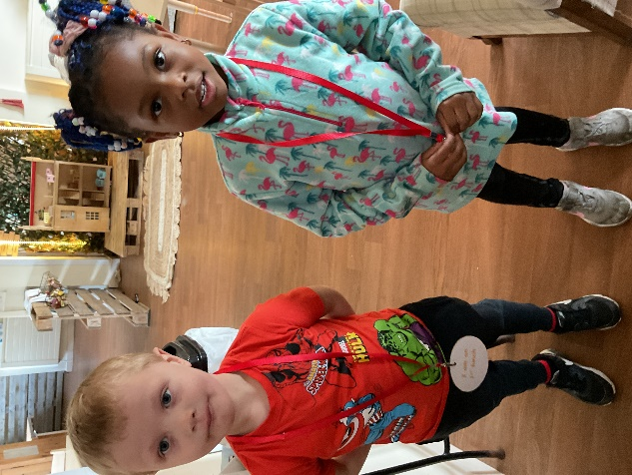

I understand and respond to the routines of my day. I need you to involve me in these routines and develop my sense of ownership and independence. – Realising the Ambition 2020:27

Star moments:

We have really enjoyed all the star moment information you have share with us on what your child has been up to or achieved. These are displayed for all the children to see and share their adventures. Once they have been taken down, we place them in a folder to allow the children to revisit their adventures or achievements whenever they wish, this is a lovely way for the staff and children to spend time engaged with your child to share their exciting event and giving your child a sense of identity, self-confidence and a sense of belonging. Please do keep sending them in.

ACHIEVING - Being supported and guided in their learning and in the development of their skills, confidence and self-esteem at home, at school, and in the community – SHANARRI – GIRFEC 2010

Learning Journals:

Staff are working hard to ensure we keep your child’s learning journal up to date on what’s been happening at nursery and the learning your child has been involved in. We would love to hear your thoughts on the posts, please comment or ask questions as well as continue to share news from home we love to share this with your child and your feedback allows staff to continue to make plans. If you are having issues with logging in to your child’s learning journal, please let us know and we can resend your login details.

Communication:

We continue to look at the ways we are sharing information with you all, and your feedback on this is welcomed. From the last stay and play session some parents highlighted they would like more ideas for activities that will support their child’s learning, following on from the feedback they are receiving on their child’s focus week. We have discussed this and where possible suggest some areas of fun and learning that can be extended to the home.
If you have any further suggestions, comments or complements please send an email to mailbox@smilechildcare.org or share with the staff members.

Parents as partners:

We continue to look at ways we can develop our relationships with parents, allowing them to feel part of the nursery. If there is something you would like to share with us, maybe a story, dressing up clothes from different cultures please talk to a member of staff, we would love to share your skills, cultures, and celebrations with all the children. If you have any resources at home, you think would be of interest to the children please do speak to a staff member we are always looking at different ways to include the children’s home life into the nursery to enhance learning for all the children. Ideas for thought –

- Would you like to come read to the children in your home language?
- Do you have any talents you would like to share with the children?
- Do you have any interesting art at home. We would be delighted to work with you to share with all the children.
- Do you play musical instruments, could you join us for song time?
ECO -Schools update:
We continue to support the children in their Eco journey, the children continue to keep our garden litter free throughout the year, and they use this task to support learning. We have also been looking at how we can continue to encourage wildlife into the garden, the children have noticed how it is getting colder, and the ground is hard, they noticed that there are no leaves or berries left on our trees and bushes. Through discussions and looking at books the children have decided to add bird feeders to the gardens to help the hungry birds. They have really enjoyed looking at the different birds that have come for food and identifying what types they are. All this learning is supporting us in our journey in Bio – diversity.

Meet the team:

Hello, my name is Natalie I have been working at smilechildcare as a practitioner since September 24. I have 18 years’ experience in childcare, I took a short career change and missed it so now am back.

Staff training:
Our staff have been busy completing lots of training over the past few months:

Donna – Child protection level 4, HENRY
Danielle and Courtney – sign along
Chloe – Pondering pedagogy
Dawn Moorehead – Child Protection level 4

As well as external training all staff are completing many internal training courses to enhance their knowledge on legislation, health and safety and staff wellbeing.

Millie’s Mark:

Did you know we have maintained our Millie’s Mar accreditation. Millie’s Mark is a national recognition for going above and beyond the minimum requirements in paediatric first aid. If you would like to find out more information, please go to our brand-new web page https://smilechildcare.org, another huge achievement for all smilechildcare’s staff.

UNCRC (United Nations Convention of the Rights of the Child)– children’s rights Article 7
smilechildcare incorporate UNCRC/children’s rights principles into everyday practice for our policies and procedures, to hands on working with families. Over the next few months, we will be highlighting several different articles from the UNCRC and exploring with you how we implement them and what this means for your child. The months of October and November we will be looking at article 7, please look out for further information on this. If you would like more information on UNCRC please go to parent club.
https://www.parentclub.scot/articles/further-information-about-childrens-rights-scotland
Outdoor clothing:
I have recently sent out information to support you to dress your child appropriately throughout the winter months whilst at nursery. It is our goal to continue to offer outdoor play in all weathers and children will have the freedom to explore all the elements and enjoy it if they are dressed appropriately. Please ensure your child has a warm jacket, proper foot wear including warm socks and a hat. Can we also ask you to name all of your child’s clothing and footwear.

Winter Activities:

Throughout the month of December, there will be lots of fun, creative and imaginative Christmas/winter activates for the children to participate in if they choose to. We will share these exciting activities on your child’s E journal so please ensure you check regularly.

As we quickly near the big day, yes Christmas is fast approaching, please find below some important information.

Dates for your diary:
Christmas lunch (for children attending on this date) Wednesday 11th December 2024
Christmas Family Firepit Gathering
We would like to invite all our families into the nursery to join us for singing, warm drinks and toasted marshmallows round the firepit on Tuesday 10th of December 5.00pm to 6.30pm.

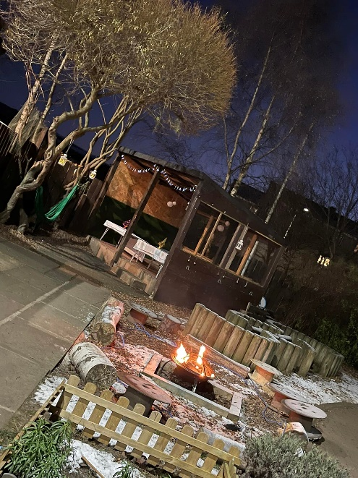

Please look out for your invitations, bring your singing voice and look forward to a lovely evening.

Dates for end of term:
Term time families last day – Friday 20th December 2024
Full Year families end of term – Monday 23rd December 2024
Return to nursery Full year children – Monday 6th January 2025
Return to nursery Term time children – Tuesday 7th January 2025

Social Media

We have a Facebook Business page and a Twitter page, where we share snapshots of what the children have been enjoying, experiencing, learning and exploring while in Nursery.

Smilechildcare | Facebook
smilechildcareedinburgh(@smilechildcare1)/Twitter
http://smilechildcare.org

For your information:
We’re here for you | Parent Club

Contents - Play strategy for Scotland: our vision - gov.scot

All the staff at smilechildcare would like to wish all our families a wonderful holiday period and a Happy New Year.



